**```Burkina Faso- Mossi- Biga (Biiga)**

**Biga figurine of the Mossi culture of Burkina Faso. Size : 13.77 inches, Wood, Weight : 0.599 pounds, First half 20 th century.   
Biga means child and is an educational object for girls among the Mossi of Burkina Faso to prepare the girls for their future rolls as mothers. Although the primary use of these biga is for education, some also hold importance for adult women, and often times a woman will bring her biga when she departs her father's home to live with her new husband. In this case the roll of the figure becomes one of fertility.**

**Biga were carved from wood and could be covered in pieces of leather as in this example. The arms and legs are not represented but the doll still bears breasts to symbolize motherhood. The shape of the head reflects the tribal origin, with hair shaped in a crest and with facial scars. Over the years, the girl will carry and hold the doll and anoint it with butter and oils. While some figurines are eventually discarded, others are passed down or inherited from a family member. In this case they represent the female family lineage.**

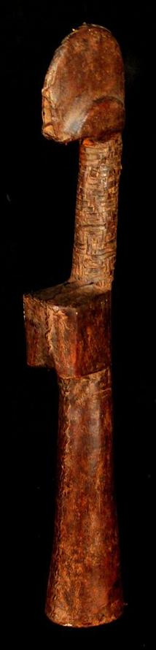

**The aniconic aspect of these figurines is also important in this respect, because they represent not an individual's appearance but the abstract identity of the familial lineage of the women of the local group. As such they are carriers of familial maternal identity. This is one aspect of how in a preliterate society that historical memory can be passed down the generations.**